**Project' Details**

This project aims to design and develop a backend  **admin should be able to change his password if he wants, he should be able to:**

● Manage the products in the store including categorizing them  
● Browse the list of users who have signed up and be able to search users  
● See purchase reports filtered by date and category

**GitHub Link :**

## <https://github.com/Farahala/full-stack-Projects/tree/phase3>

## Product Backlog:

1. Create database and tables in MYSQL DB
2. Connect the database to the project.
3. Import the Spring boot and tyremlte
4. Create a servlet to get requests and send responses to the JSP files
5. Debug and Test the project.
6. Create models classes.

**Libraries used:**

1. Mydb Using MYSQL
2. Hibernate
3. JSP/Servlet

We are working with agile methodologies So I divided the project in 2 sprints at the end of the sprint i check the Backlog .

**Sprint 1:**

* Setup Database
* Setup the server
* Create the Table in DB and
* Start to implemt the View .
* Start to Implement the controller .
* Start to implement the services
* Start to Implement theModel.

1. **Sprint 2:**

* Class Report
* Improvements in Navigation
* Test and degup the project
  + My flow chart , as way of thinking .

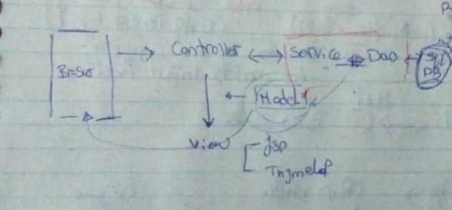

- Project Structure on IDE

You can run from the Phase3demoappApplication

run as a java appilaction

Pls first to put your Database configuration correctly

- 